**Experiment 6: Date:** 14/03/2023

**Aim:**

Familiarization of Linux Commands

**Course Outcome(CO2):**

Perform system administration task

**Procedure:**

1. grep :- Filtering and Searching content easily

$gerp 34 Mark

Output:



* 1. grep -i :- Case insensitive search of a particular content￼

$grep -i 42 Mark

Output:



* 1. grep -v :- Exclude that content during search￼￼￼￼

$grep -v 42 Mark

Output:



* 1. grep -A1 :- Specific content and one line after the content

$grep -A1 Maths Mark

Output:



* 1. grep -B1 :- Specific content and one line before the content

$grep -B1 Maths Mark

Output:



* 1. grep -C1 :- Specific content and one lone before and after the content.

$gerp -C1 Maths Mark

Output:

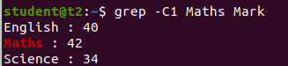

1. head :- Used to display the first content of the file(Top 10 lines by default)

$head numbers

Output:-

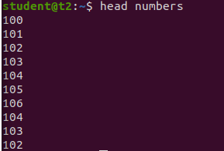

* 1. head -number filename:- Specific number of lines

$head -5 numbers

Output:

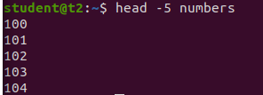

1. tail:- Used to display last contents of a file( last 10 by default)

$tail numbers

Output:

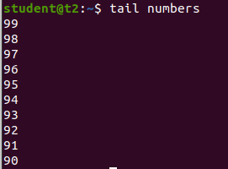

* 1. tail -number filename :- Specific number of content from last

￼￼$tail -5 numbers

Output:

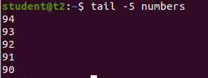

1. mv :- move from one location to another or it can be used to rename a file. Content will be overwritten.

$mv numbers Mark

Output:-

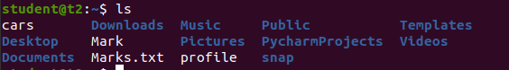

* 1. mv -b :- To take backup of a file while moving.

$mv -b Mark profile

Output:

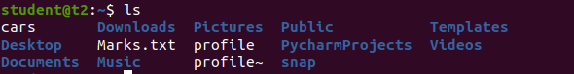

* 1. mv -i :- Prompt confirmation from user before overwriting.

$mv -i Marks.txt profile

Output:



**Result:**

Output displayed successfully and CO2 was obtained.